Week Ending: |  | DAY: |  |  |  |  | Subject: Mathematics
Duration: |  |  |  |  |  |  | Strand: Data
Class: B1 (One) |  | Class Size: |  |  |  |  | Sub Strand: Data Collection And Organization
Content Standard:  B1.4.1.1 Organize, represent and interpret data. |  |  |  | Indicator:  B1.4.1.1.2 Organize a given set of data into three categories, find the total number of data points and determine how many are in each category and compare the number in any two category |  |  |  |  | Lesson:  1 OF 1
Performance Indicator:  - Learners can organize data with a given criteria.. |  |  |  |  |  | Core Competencies:  Problem Solving skills; Critical Thinking; Justification of Ideas; Collaborative Learning; Personal
Teaching/ Learning Resources |  |  | Flowers of different kinds, bottle caps, fruits,pictures of animals and birds
NEW WORDS |  |  | Collecting, data, interpret
References: Mathematics Curriculum Pg. 18
DAYS | PHASE 1: STARTER |  |  |  | PHASE 2: MAIN |  |  | PHASE 3: REFLECTION
Monday | Play, how many to make 10. Call out a number between 1 and 9. Learners call out a number that must he added to that number to make 10. E.g. 8 2,  6 4,  9 1.  Have learners look at the picture and tell the quantity of each item. Let them work in pairs. |  |  |  | Take the class outside. Walk round with them and ask them to pick anything that is attractive to them, such as flowers, pebbles, leaves (be careful of dangerous flowers and leaves), etc.  Let them assemble the materials they brought according to sameness and count for each category.  Example:  stones ______,  pebbles _____,  flowers _____  brainstorm learners for the game they like best: Write these games on the board. E.g. Ampe, football, netball  Learners go and make a stroke against the game they like best. They should count and tell the number in each category.  Draw toffee, chocolate and ice cream on the board.  Learners make a stroke against the sweet he/she likes. They count to find the number in each category:  toffee _______  chocolate _______  ice cream _______ |  |  | Ask learners to tell you what they have learnt  Homework  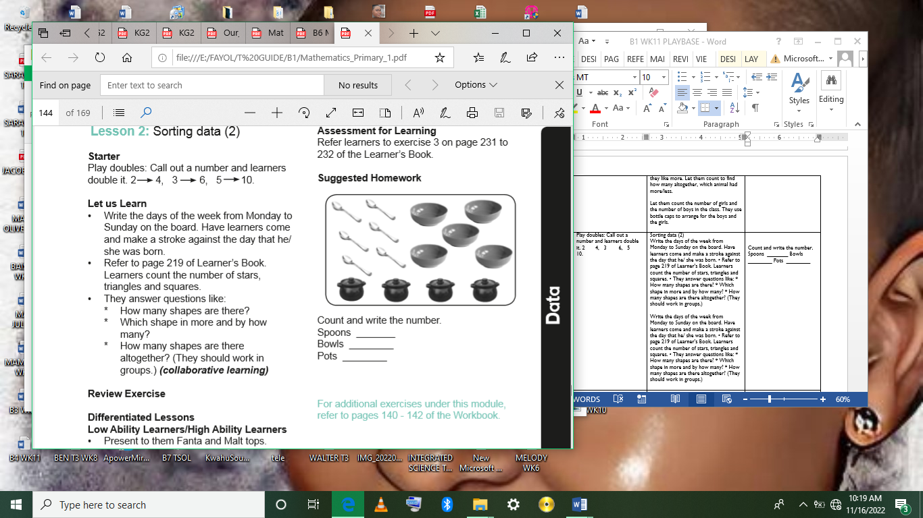  Count and write the number.  Spoons _______  Bowls ________  Pots ________
Tuesday | Play “Make 10”. Show fingers, and learners add a number to make 10. |  |  |  | Draw a banana and apple on the board.  Let them answer the questions.  • How many learners like bananas?  • How many learners like apples?  Guide them to tally their favorite fruits on the board.  Display pictures of animals on the table. Call each learner to come and pick the animal he/she likes best.  They paste it against the animal they like best.  Dog _______  Cat _______  Monkey _____  1. How many like cats?  2. How many like dog?  3. How many like monkey? |  |  | Ask learners to tell you what they have learnt  Homework  Count and write the number of these items in your house.  1 Spoons _______  2 Cups ________  3 Cooking utensils________
Wednesday | Play a game of “I spy” with learners using riddles that describes the relative position of various object, e.g. “I spy something that is beside the chair, in front of the bookcase, etc. |  |  |  | Have a picture of learners in front of the class and ask the learners to use two different objects to represent the number of males and females.  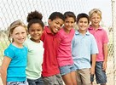  Let learners represent the number of boys with a red Lego block, and represent the number of girls with a blue Lego block.  Boys Girls  Assessment: let learners solve several examples |  |  | Ask learners to tell you what they have learnt  Give learners individual or home task
Thursday | Play a game of “I spy” with learners using riddles that describes the relative position of various object, e.g. “I spy something that is beside the chair, in front of the bookcase, etc. |  |  |  | Bring a picture of animals in front of the class and ask the learners;  How many different types of fruits are there?  How many people like mango?  Have learners to use two different objects to represent the number of males and females animals.  Let learners represent the number of males with a red Lego block, and represent the number of females with a blue Lego block.  Using the scenario in day one lesson, let learners solve simple problems (i.e. how many altogether, how many more or less).  In the example, there were four boys and two girls in the picture, 4 boys and 2 girls. Altogether there are 6 pupils in the picture.  Let learners use the Lego blocks to demonstrate this fact. |  |  | Ask learners to tell you what they have learnt  Give learners individual or home task
Friday | Play games and recite rhymes that learners are familiar with to begin the lesson.  Ask learners questions to review their understanding in the previous lesson. |  |  |  | Bring a picture of objects in front of the class and ask the learners to use two different category to represent the number of natural and man-made.  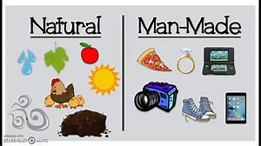  Let learners represent the number of natural items with a yellow Lego block, and represent the number of man-made items with a green Lego block.  Natural items Man-made items  Assessment: let learners solve several examples |  |  | Ask learners to tell you what they have learnt  Give learners individual or home task

